**To run the code:**

1. Need to upload the **CookPad_Sushi_Sandwich_Sushidi.ipynb**
2. If it is google collab environment:

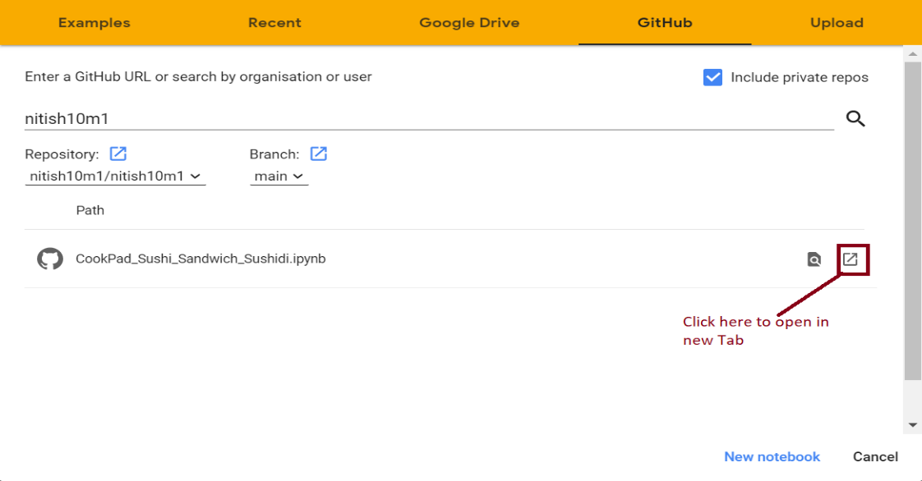

1. Please mount the drive by clicking
2. Go to Runtime, select “Restart and run all”
3. It will run the application and output will be printed as well as saved under “sushi_or_sandwich” -> sushidi -> *.jpg